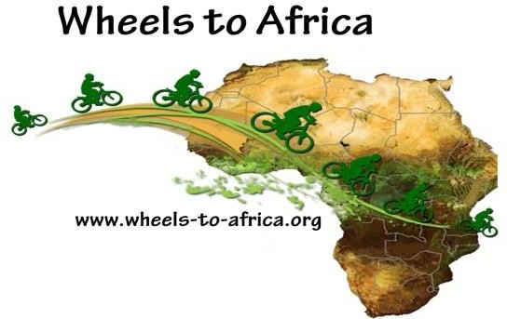
SATURDAY JANUARY 22nd
9 am to 2 pm
Front Parking Lot at
Westlake High School
100 Lakeview Canyon Rd,
Thousand Oaks, CA 91362

BIKE COLLECTION
Wheels to Africa is a 501(c) 3 Non-Profit that was founded in 2005, since then there have been over 7,500 bikes collected and donated to non-profit organizations in Africa:
- House of Happiness Children’s Home in Tanzania
- Ujamaa Children’s Home in Tanzania
- Bicycle Empowerment Network, Namibia
- Village Bicycle Project, Ghana
We take all bikes, except rusted bikes. We also need cash donations to cover the expenses of storage and shipping. We provide tax deductible receipts.
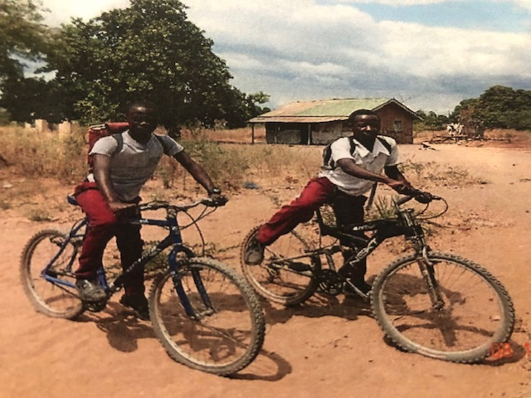
BIKES CHANGE LIVES
HELP CHILDREN AND FAMILIES
- GET TO SCHOOL
- GO TO THE DOCTOR
- GET WATER AND FOOD

TO LEARN MORE PLEASE VISIT WWW.WHEELS-TO-AFRICA.ORG

